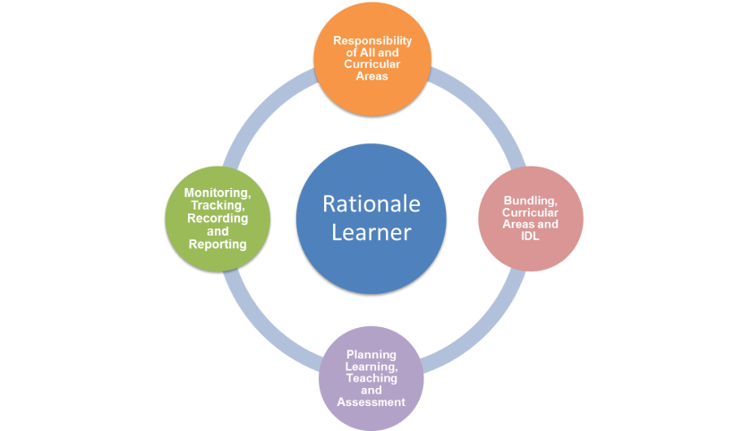

**Quality Assurance and Moderation Record of CfE Achievement of a Level Moderation Activity**

|  |  |
| --- | --- |
| **Curricular Area** |  |

|  |  |  |
| --- | --- | --- |
|  | **Moderation Criteria** | **Feedback** |
|
| **PLANNING FOR ASSESSMENT** | **Bundles of E’s and O’s** | **Bundles of Es and Os** |
| The bundle of E’s and O’s fit well together to provide a coherent learning experience |
| **Evaluating Learning Intentions and Success Criteria** | **Evaluating LI and SC** |
| The LIs and SC relate clearly to the E’s and O’s / Benchmarks selected and reflect the key learning being assessed |
| The LIs and SC reflect the level of challenge described in the language of the E’s and O’s (eg describe, compare, evaluate) |
| SC are clear, relevant and measurable definitions of what success in learning looks like. |
| **LEARNING EXPERIENCE and ASSESSMENT APPROACHES** | **Quality of Learning Experiences and Assessment Approaches** | **Quality of Learning, Teaching and Assessment** |
| The assessment approaches are appropriate for the ES and Os, success criteria / Benchmarks |
| The level of support and challenge in the learning experiences and assessment approaches is appropriate. |
| The feedback to learners is related to the success criteria and allows them to set targets for their next steps in their learning |
| The assessment evidence brings together a number of Es and Os across organiser(s) and is appropriately balanced. |
| The assessment evidence demonstrates **breadth, challenge and application** of learning in new and unfamiliar contexts. |
|  | **Agreed Level** |  |